|  |  |  |
| --- | --- | --- |
|  |  |  |
| **CAN THO UNIVERSITY SOFTWARE CENTER**  **MEKONG DELTA - APTECH** |

**SEMESTER EPROJECT – I**

**HDD AIR CONDITIONER**

|  |  |
| --- | --- |
| **Instructor:** | **Class: CP2296F09** |
| Ms. Thai Nguyen Vo Thong | **Group: 1** |
| **Students:**  1. Student1456970 - DUC NGUYEN TIEN  2. Student1456965 - HAN PHAN LE KHA  3. Student1456968 - DAT HUYNH TUAN |

Can Tho, 10 June 2023



This is to certify that

**Mr**: DUC NGUYEN TIEN

**Ms**: HAN PHAN LE KHA

**Mr**: DAT HUYNH TUAN

Has successfully Design & Developed

Submitted by: DUC NGUYEN TIEN

Date of Issue: 10/06/2023

Authorized Signature: NGUYEN VO THONG THAI

**Problem definition**

**Current situation before having a website:**

The promotion of products to consumers is still difficult, relying solely on word-of-mouth sales. The advertising section has not been developed yet, and the approach to information about the air conditioning system that the company is operating is still facing many difficulties. Customers need to search for information from many different sources and often have difficulty finding necessary information about products, services, and usage instructions. The communication and contact methods between the company and consumers are not convenient and fast.

**Challenges and limitations:**

1. Pricing and detailed product images are crucial and the most important factors that customers are concerned about.

2. Functionality and performance of the product.

3. Payment and shipping methods

4. Promotional programs

5. Customer care services

6. Warranty and repair services

7. Product distribution locations.

8. Comment on the product

**Website Concept:** The proposed website concept for the AC project will encompass the following key elements:

1. Comprehensive Product Information: The website will provide detailed and up-to-date information about the company's air conditioning systems, including specifications, features, energy efficiency, and installation guidelines. This will enable customers to make informed decisions and better understand the products.
2. User-Friendly Interface: The website will have a user-friendly interface, ensuring easy navigation and intuitive access to different sections. A clear and organized layout will facilitate a seamless browsing experience for visitors.
3. Online Booking and Service Requests: Customers will have the convenience of booking AC installation services or requesting maintenance and repairs through the website. This feature will streamline the process and provide timely assistance to customers.
4. Interactive Communication Channels: The website will incorporate interactive communication channels such as live chat or contact forms, allowing customers to engage with the company's representatives and get prompt responses to their inquiries

**Convenient and Advantage:**

1. By implementing the proposed website concept, the AC project aims to address the existing challenges, improve customer accessibility to information, and enhance communication between the company and its customers. This will ultimately contribute to the growth and success of the project.
2. In conclusion, the problem definition in the AC project emphasizes the need for a website to overcome the current limitations in promoting products, accessing information, and facilitating effective communication. The proposed website concept provides a roadmap for developing a user-friendly platform that will enhance the overall experience for customers and support the objectives of the AC project.

**Customer Requirement Specification(CRS)**

**Client:** HDD Air Conditioner Company

**Business/Project Objective:**

HDD Air Conditioner Company is a start-up company in Can Tho, Vietnam in 2022, which is having a bit of difficulty in approaching attracting customers' attention from other companies in Vietnamese market. Along with the development of online shopping, creating a website to reach out to customers is essential. This website allows customers to easily access the specifications, models, promotions, and customer reviews, as well as sending questions. All of these bring trust and help customers make purchase decisions faster.

**Input provided by Client:**

* Products:
* Input: Information about AC types.
* Output: Classification of AC types. Detailed about AC types.
* Home Page:
* Input: Company logo, Product general info, Sign in/sign up form.
* Output: “Successful sign up” Notice.
* About page
* Input: Brand value, goals
* Service
* Input: Terms and conditions; Warranty Information
* FAQ
* Input: General Question
* Feedback:
* Input: Customer name, email, service feedback
* Output: “Sent” Notice.

**Expected Delivery Dates:** 10/06/2023

**List of deliverables:**

* Document:
* Checklist of validations
* Submission Checklist
* Site map
* Architecture and Design of the Project
* Website contains the following pages:
* Home page
* Product
* About page
* Service
* Feedback
* FAQ

**Hardware Requirements:**

* Intel Core i3/i5 Processor or higher
* 8 GB RAM or above
* Color SVGA
* 500 GB Hard Disk space
* Mouse
* Keyboard

**Software Requirements:**

* Server:
* Operating systems Windows sever versions
* Client:
* Popular web browsers like Edge, Chrome, Mozilla Firefox, Safari

**Scope of the Work (in brief):**

* Home page
* Product page
* About page
* Service page
* Feedback page
* FAQ page

**Checklist of validations**

|  |  |
| --- | --- |
| **Option** | **Validated** |
| Do all text link lead to the approriate Web site? |  |
| Do all the image links lead to the appropriate Web site? |  |
| Are all the images and links clearly visible on the page? |  |
| Is the Web page opening properly in all the tested Web browsers? |  |
| Is the Web page taking too long to load? |  |
| Is the navigation sequence correct through all the Web pages on the site? |  |
| Is the JavaScript code working as expected in all click events? |  |

**Submission Checklist**

|  |  |  |  |  |  |
| --- | --- | --- | --- | --- | --- |
| **Sr.No.** | **Particulars** | **Yes** | **No** | **NA** | **Comments** |
| 1. | Are all the users able to view the images and links? |  |  |  |  |
| 2. | Have all the view, modules, and controllers been properly integrated and is the site functional as a Single Page application? |  |  |  |  |
| 3. | Are the GUI contents devoid of spelling mistakes? |  |  |  |  |
| 4. | Is the application user-friendly? |  |  |  |  |
| 5. | Is the Web site launching correctly in the browser? |  |  |  |  |

**Site map**

**Architecture and Design of the Project**

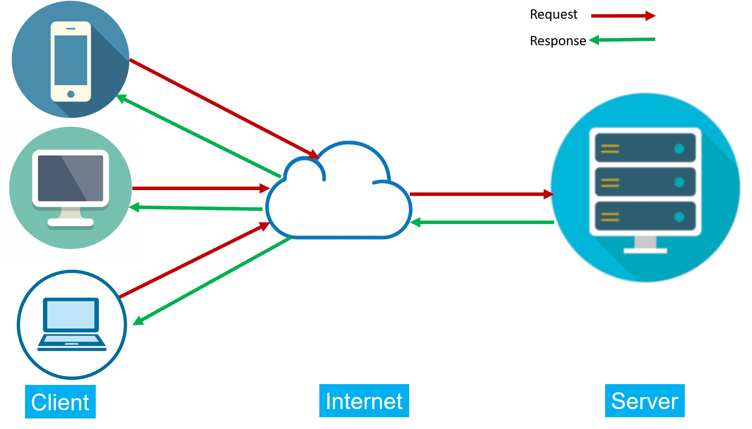

**Task sheet**

|  |  |  |  |  |  |  |  |
| --- | --- | --- | --- | --- | --- | --- | --- |
| **Project Ref. No.:** | | **Project**  **Title:** | **Activity Plan Prepared By:** | **Date of Preparation of Actitvity Plan:** | | | |
| **Sr.No.** | **Task** | **Actual Start Date** | **Actual Days** | **Team Mate Names** | **Status** |
| 1. | Template of Website + HTML(Home Page) | HDD Air Conditioner | 10-May-2023 | 11-May-2023 | 10 Days | DUC NGUYEN TIEN | 100% |
| 2. | Customer Requirement Specification | 11-May-2023 | 10 Days | HAN PHAN LE KHA | 100% |
| 3. | Problem definition | 11-May-2023 | 10 Days | DAT HUYNH TUAN | 100% |
| 4. |  | 20-May-2023  30-May-2023 | 21-May-2023 | 10 Days | DUC NGUYEN TIEN | 100% |
| 5. |  | 21-May-2023 | 10 Days | HAN PHAN LE KHA | 100% |
| 6. |  | 21-May-2023 | 10 Days | DAT HUYNH TUAN | 100% |
| 7. |  | 31-May-2023 | 10 Days | DUC NGUYEN TIEN | 100% |
| 8. |  | 31-May-2023 | 10 Days | HAN PHAN LE KHA | 100% |
| 9. |  | 31-May-2023 | 10 Days | DAT HUYNH TUAN | 100% |